Testing foods for starch

Circle the laboratory instruments you will need for this experiment.

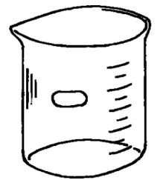 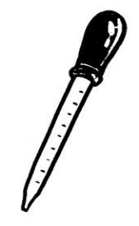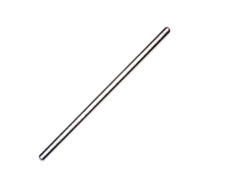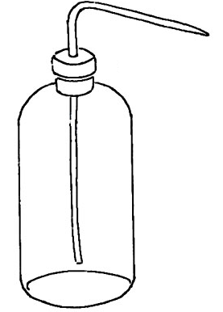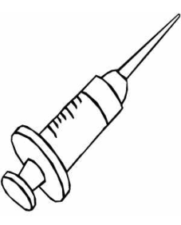

 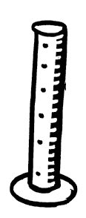 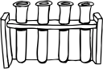 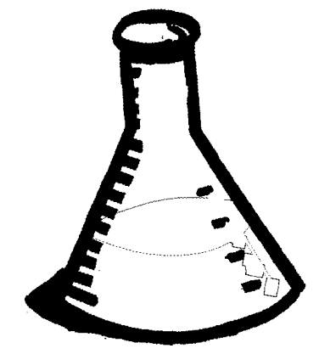

Next to each name draw a sketch of the instruments above.

|  |  |  |  |
| --- | --- | --- | --- |
| Test tube |  | Wash bottle |  |
| Beaker |  | Test tube rack |  |
| Glass rod |  |  |  |
| Dropper |  |  |  |

|  |  |
| --- | --- |
| Equipment | Test tube, beaker, glass rod, dropper, wash bottle, test tube rack |
| Materials | * starch, potato, wheatmeal, sucrose; * iodine solution; * distilled water. |
| Procedure | 1) Add 10 cm3 of water and some starch to a clean test tube. (Our sample)  2) Add 10 cm3 of water and some wheatmeal to a clean test tube.  3) Add 10 cm3 of water and some sucrose to a clean test tube.  4) Take a piece of potato. |
| Activity | 5) Add a few drops of iodine solution to each of the items and observe the change of colour of the iodine (if any). Anything that turns blue-black contains starch.  **Record the results in a table:**   |  |  |  | | --- | --- | --- | | **ITEM** | **Did iodine turn blue or blue-black** | **Was there starch in the item?** | | Wheatmeal |  |  | | Sucrose |  |  | | Potato |  |  | |